Lagged cross-correlation: GBPUSD and USDCHF
Method 12 / daily log returns / K_max=10 / Alpari D1 full available history

Study setup
Logical pair: GBPUSD , USDCHF
Broker symbols: GBPUSD_i , USDCHF_i
Snapshot: 2026-11-03_majors_alpari_D1
Timeframe: D1
Matched return window: 1999-01-05 to 2026-11-02 (UTC bar dates)
Matched return count n: 7201
Dropped unfinished last bar dated 2026-11-03 UTC after a tick-volume check against the prior complete day.
Lag definition: rho_X->Y(k) = Corr(x_t, y_{t+k}) on matched D1 bars
K_max = 10; headline lag k = 1 (both directions)
Complete matched rows (Excel): GBPUSD-USDCHF_Lagged_D1.xlsx
Complete matched rows (HTML table): GBPUSD-USDCHF_Lagged_D1_data.html

Method carried forward
Lagged cross-correlation measures Pearson correlation between matched daily log returns of close, ln(close_t / close_t-1), after shifting one series forward by k bars on the matched panel. Quotes are not inverted. rho_{X->Y}(k) = Corr(x_t, y_{t+k}) with n_k = n - k. K_max = 10 is fixed before estimation. The headline is the pre-specified lag k = 1 in both directions. k = 0 is the same-bar side check. The lag inside 1..10 with the largest absolute rho is stored as a descriptive column only; it is not a selected result. This is a linear screen, not proof of forecast edge, economic cause, or a trading signal.

Results (headline k=1)
rho_GBPUSD->USDCHF(1): -0.004628 (n=7200)
95% Fisher interval GBPUSD->USDCHF: [-0.027724, 0.018473]
rho_USDCHF->GBPUSD(1): 0.012431 (n=7200)
95% Fisher interval USDCHF->GBPUSD: [-0.010671, 0.035520]
Same-bar rho(k=0): -0.486083
Largest |rho| among k=1..10 (descriptive only, not selected): GBPUSD->USDCHF k=9 rho=0.030293; USDCHF->GBPUSD k=8 rho=-0.021538

CCF table
k | rho_GBPUSD_to_USDCHF | n_GBPUSD_to_USDCHF | rho_USDCHF_to_GBPUSD | n_USDCHF_to_GBPUSD
0 | -0.48608266 | 7201 | -0.48608266 | 7201
1 | -0.00462765 | 7200 | 0.01243132 | 7200
2 | 0.00144505 | 7199 | -0.007574 | 7199
3 | -0.00696318 | 7198 | 0.00280554 | 7198
4 | 0.00547552 | 7197 | 0.00152684 | 7197
5 | -0.01680681 | 7196 | 0.01279907 | 7196
6 | 0.0136997 | 7195 | -0.00805777 | 7195
7 | 0.00419075 | 7194 | -0.01520016 | 7194
8 | -0.00610882 | 7193 | -0.02153791 | 7193
9 | 0.03029328 | 7192 | -0.002541 | 7192
10 | 0.01262089 | 7191 | 0.0043339 | 7191

Conclusion
At the pre-specified lag k=1 for GBPUSD and USDCHF, rho_{GBPUSD->USDCHF}(1) = -0.0046 (n=7200) and rho_{USDCHF->GBPUSD}(1) = 0.0124 (n=7200). Same-bar rho(k=0) = -0.4861. Largest |rho| among k=1..10 is descriptive only: GBPUSD->USDCHF at k=9 (0.0303); USDCHF->GBPUSD at k=8 (-0.0215). This is a linear screen, not forecast proof or a trading signal.

Charts
Daily closes

Daily log returns

CCF both directions k=0..10
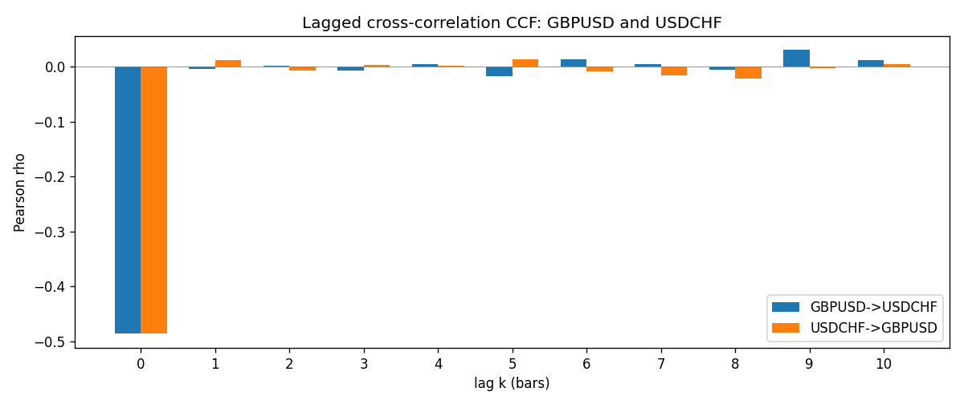

Data report
Every matched row is stored in the sibling Excel workbook named GBPUSD-USDCHF_Lagged_D1.xlsx (sheet matched_rows). The CCF sheet holds rho(k) for k=0..10. Embedding all rows as a Word table is impractical; the Word file holds column summaries and the first and last 15 rows.
Columns: time, GBPUSD_open, USDCHF_open, GBPUSD_high, USDCHF_high, GBPUSD_low, USDCHF_low, GBPUSD_close, USDCHF_close, GBPUSD_tick_volume, USDCHF_tick_volume, GBPUSD_spread, USDCHF_spread, GBPUSD_real_volume, USDCHF_real_volume, GBPUSD_log_return, USDCHF_log_return
Column summaries (matched calculation rows)
column | count | mean | std | min | 25% | 50% | 75% | max
GBPUSD_open | 7201 | 1.5160785 | 0.218271 | 1.06854 | 1.32499 | 1.51142 | 1.63167 | 2.1066
USDCHF_open | 7201 | 1.0982956 | 0.25264095 | 0.72022 | 0.92069 | 0.99019 | 1.2387 | 1.8219
GBPUSD_high | 7201 | 1.5223771 | 0.21884011 | 1.08366 | 1.32979 | 1.5182 | 1.6384 | 2.1161
USDCHF_high | 7201 | 1.1035944 | 0.25438893 | 0.73305 | 0.92495 | 0.99377 | 1.2436 | 1.8313
GBPUSD_low | 7201 | 1.5097512 | 0.21749696 | 1.03518 | 1.31949 | 1.50336 | 1.6244 | 2.0983
USDCHF_low | 7201 | 1.0931703 | 0.25105533 | 0.08565 | 0.91742 | 0.9867 | 1.2331 | 1.8121
GBPUSD_close | 7201 | 1.5161456 | 0.2182303 | 1.06879 | 1.3251 | 1.5114 | 1.63212 | 2.1065
USDCHF_close | 7201 | 1.0982864 | 0.25254184 | 0.72025 | 0.92098 | 0.9902 | 1.2387 | 1.8217
GBPUSD_tick_volume | 7201 | 94828.085 | 153546.21 | 62 | 10002 | 52900 | 91806 | 1273370
USDCHF_tick_volume | 7201 | 74189.26 | 113409.95 | 18 | 12770 | 40195 | 70240 | 858589
GBPUSD_spread | 7201 | 26.971115 | 19.193539 | 0 | 11 | 20 | 50 | 50
USDCHF_spread | 7201 | 26.114567 | 24.723753 | 0 | 5 | 16 | 50 | 100
GBPUSD_real_volume | 7201 | 3.5560898e+09 | 8.4438214e+10 | 0 | 0 | 0 | 0 | 2.4038164e+12
USDCHF_real_volume | 7201 | 2.3236557e+10 | 8.9041498e+10 | 0 | 0 | 0 | 0 | 1.9331921e+12
GBPUSD_log_return | 7201 | -2.316e-05 | 0.00564524 | -0.08388241 | -0.00312969 | 3.242e-05 | 0.00318104 | 0.03112653
USDCHF_log_return | 7201 | -7.148e-05 | 0.00659332 | -0.19545699 | -0.00335964 | 8.06e-05 | 0.00331782 | 0.09051364
First 15 matched rows (selected columns)
time | GBPUSD_close | USDCHF_close | GBPUSD_log_return | USDCHF_log_return
1999-01-05 | 1.6547 | 1.3724 | -0.0028966287 | 0.0039424743
1999-01-06 | 1.6537 | 1.3912 | -0.00060452184 | 0.013605652
1999-01-07 | 1.6502 | 1.3782 | -0.002118709 | -0.0093883841
1999-01-08 | 1.6405 | 1.3935 | -0.0058954193 | 0.011040268
1999-01-11 | 1.6312 | 1.4009 | -0.0056851331 | 0.0052963193
1999-01-12 | 1.6349 | 1.3872 | 0.0022657001 | -0.0098275602
1999-01-13 | 1.6499 | 1.3621 | 0.0091330396 | -0.018259701
1999-01-14 | 1.6531 | 1.3588 | 0.0019376331 | -0.0024256692
1999-01-15 | 1.6502 | 1.3834 | -0.0017558204 | 0.01794228
1999-01-18 | 1.6522 | 1.379 | 0.0012112405 | -0.0031856384
1999-01-19 | 1.6553 | 1.3789 | 0.0018745281 | -7.2518946e-05
1999-01-20 | 1.6472 | 1.3889 | -0.0049053846 | 0.0072259871
1999-01-21 | 1.6524 | 1.3836 | 0.0031518998 | -0.0038232689
1999-01-22 | 1.6565 | 1.3834 | 0.0024781662 | -0.0001445609
1999-01-25 | 1.6585 | 1.3868 | 0.0012066366 | 0.0024546976
Last 15 matched rows (selected columns)
time | GBPUSD_close | USDCHF_close | GBPUSD_log_return | USDCHF_log_return
2026-10-13 | 1.32534 | 0.83244 | 0.0036434319 | -0.0024955621
2026-10-14 | 1.31884 | 0.83489 | -0.0049164679 | 0.0029388325
2026-10-15 | 1.32757 | 0.82676 | 0.0065976411 | -0.0097855323
2026-10-16 | 1.33257 | 0.82377 | 0.0037592051 | -0.0036230826
2026-10-19 | 1.33024 | 0.82677 | -0.0017500314 | 0.0036351779
2026-10-20 | 1.3377 | 0.8246 | 0.0055923442 | -0.0026281224
2026-10-21 | 1.33937 | 0.82427 | 0.0012476328 | -0.00040027413
2026-10-22 | 1.33967 | 0.82032 | 0.00022396082 | -0.0048036381
2026-10-23 | 1.33684 | 0.82497 | -0.0021146949 | 0.005652514
2026-10-26 | 1.33359 | 0.82649 | -0.0024340661 | 0.0018407959
2026-10-27 | 1.33044 | 0.82865 | -0.0023648393 | 0.0026100526
2026-10-28 | 1.33254 | 0.82781 | 0.0015771808 | -0.0010142111
2026-10-29 | 1.33733 | 0.82379 | 0.0035881935 | -0.0048680164
2026-10-30 | 1.33913 | 0.82438 | 0.0013450605 | 0.00071594559
2026-11-02 | 1.3406 | 0.81851 | 0.0010971256 | -0.0071459744

